M.C-2.5
In general the number of Flitter users is positively related (proportional) to city size. Users with fewer contacts disperse at constant density throughout the cities, while users with most contacts are likely to appear in larger cities [pic 1, node size is propotional to node’ degree].
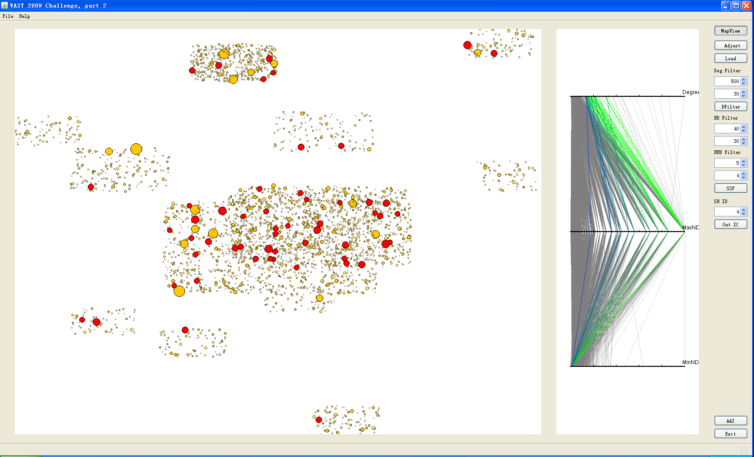
The fearless leader has contacts to all the countries so it is probable all the countries have ties to this criminal operation. Posana’s more significant concern than others since the fearless leader has most his international contacts with Posana. The middle man’s in a city near Posana, and this also contributes to our suspicion on Posana.[pic 2]
