MC2.3 Characterize the difference between your social network and the closest social structure you selected (A or B). If you include extra nodes please explain how they fit in to your scenario or analysis. Provide a Detailed Answer.

Detailed Answer:
Our social network was quite close to social structure A which we selected in previous task. Since we knew that structure A was a closer one, we took a goal-oriented way to solve this task. Our goal was to find these crucial roles, namely employee, handler, middleman and lead, as well as the relationship among them. It was easy for us to reflect node-link graph as our visualization tool to deal with such a social network data.
We treated every flitter in the social network as a node, and the number of flitter contact as degree. Our solution was to detect the suspicious node and with their links in our node-link graph, through which we may find the crucial roles and information transmission path.

First, we generated the node-link graph using our tool. Before that, the two datasets, namely Links_Table and Flitter_Names had been loaded in our data structure automatically, however, for this step flitter names was not necessary. Furthermore, as a necessary preparation, we made statistics to describe every node's degree. The format of the statistical file was like this: "Index: degree". This dataset should be loaded as well. However, the difficulty was that the large scale of nodes and links make it unreadable, to say nothing of any interactions. We realized a simple spring model as to improve the layout. After two or three times adjustment (with the button "Adjust" in the right column), over 6,000 nodes scattered in the panel under a balanceable force. Well, the size of each node represented its degree. Larger nodes’ degree, more green its links’ color, while the small degree node had blue ones. [pic1]
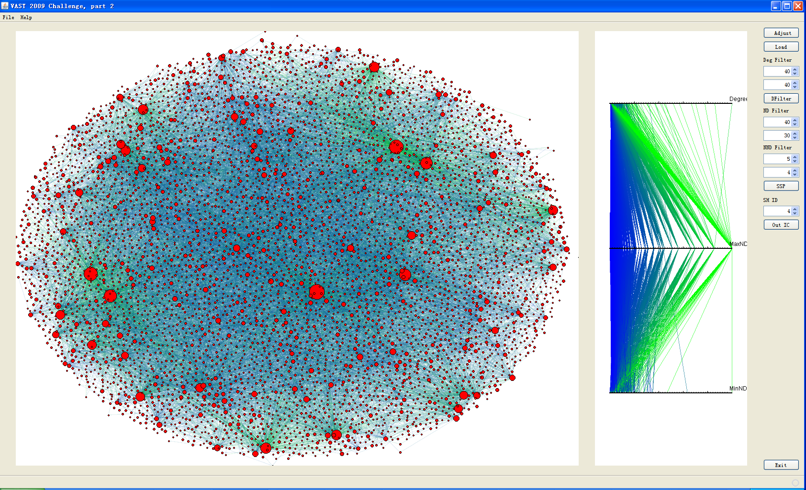
[pic1]

Second, we considered the data filtering and the interactions. To come to understand the process, we used an example as below to describe it. We designed such method: we could filter out some nodes colored red on the panel whose degree was between 38 and 42, initialized range. According to the structure offered, employee's degree should be around 40, the red nodes represented that potential employee. The yellow ones were neighbors of red ones, their degree was between 30 and 40, because employee's handlers had only 30 to 40 degree, so yellow ones could represent potential handlers. We could highlight the node by clicking on it or selecting on the parallel coordinates, and dragging the node is permitted. [pic2]
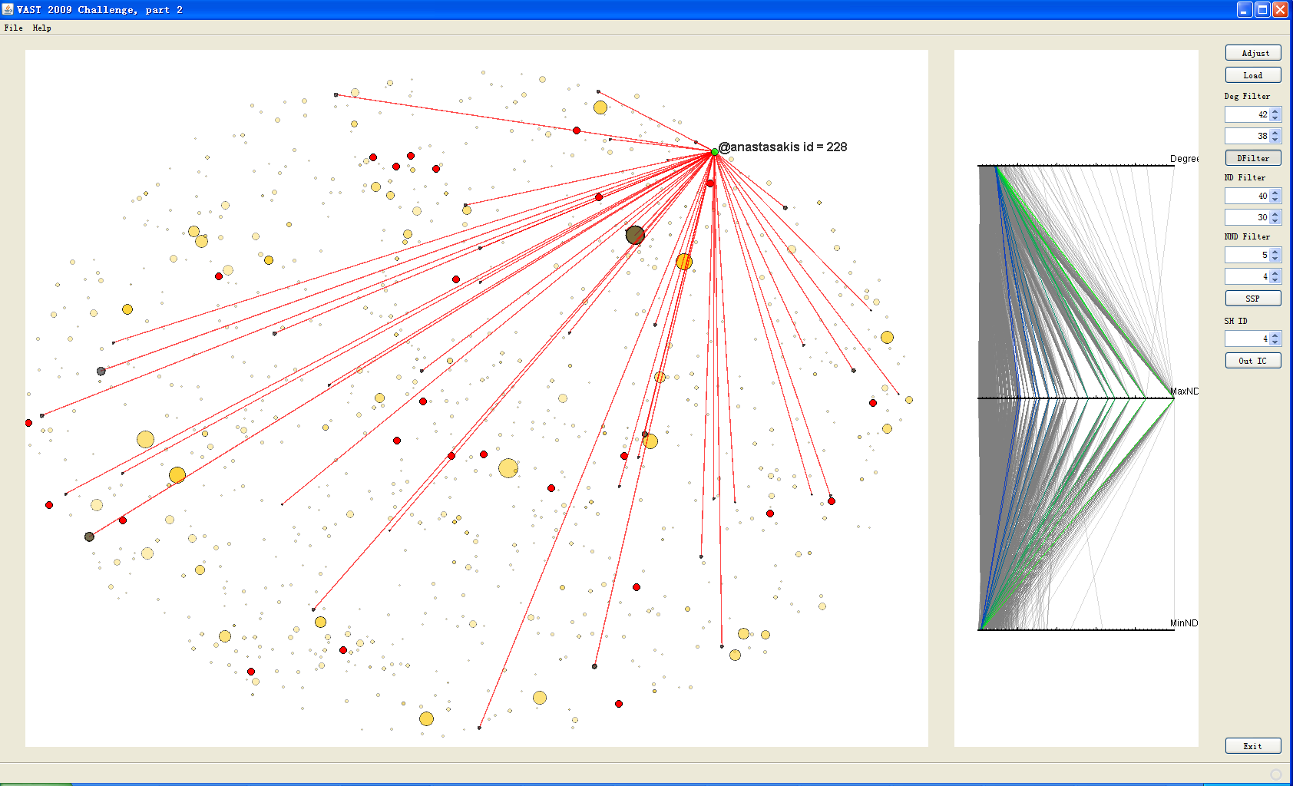
[pic2]

In addition, we would like to detect whether every yellow node had a 4 or 5-degree node, which represented potential middleman, for that middleman only connected to three handlers and one or two other nodes. We colored the potential middleman black. We would find them hard to see, because their degree was quite small. If the black nodes had 100+ degree neighbors, we would highlight the big node as pink. The model is quite clear that our work was just to click every red node to check the path from it. If the nodes’ degree and their relationship along this path all meet demand, it was a wanted path. For example, we clicked a red node No.160, which had 2 green paths to 2 handlers. Absolutely, it was not we want, because employee could only have three handlers. [pic3] Next, we clicked another red node No.66, along its three green paths, we found that three handlers did NOT share a middleman. [pic4] And next, we clicked No.100 red node, we were very pleasantly surprised to find that it was a right path. The number of No.100 ’s neighbors fell within 38 to 42, and each of its handlers had 30 to 40 neighbors, additional, they shared a middleman which linked to another 100+ degree node. So we drew the conclusion, this 100+ node was Head. [pic5]
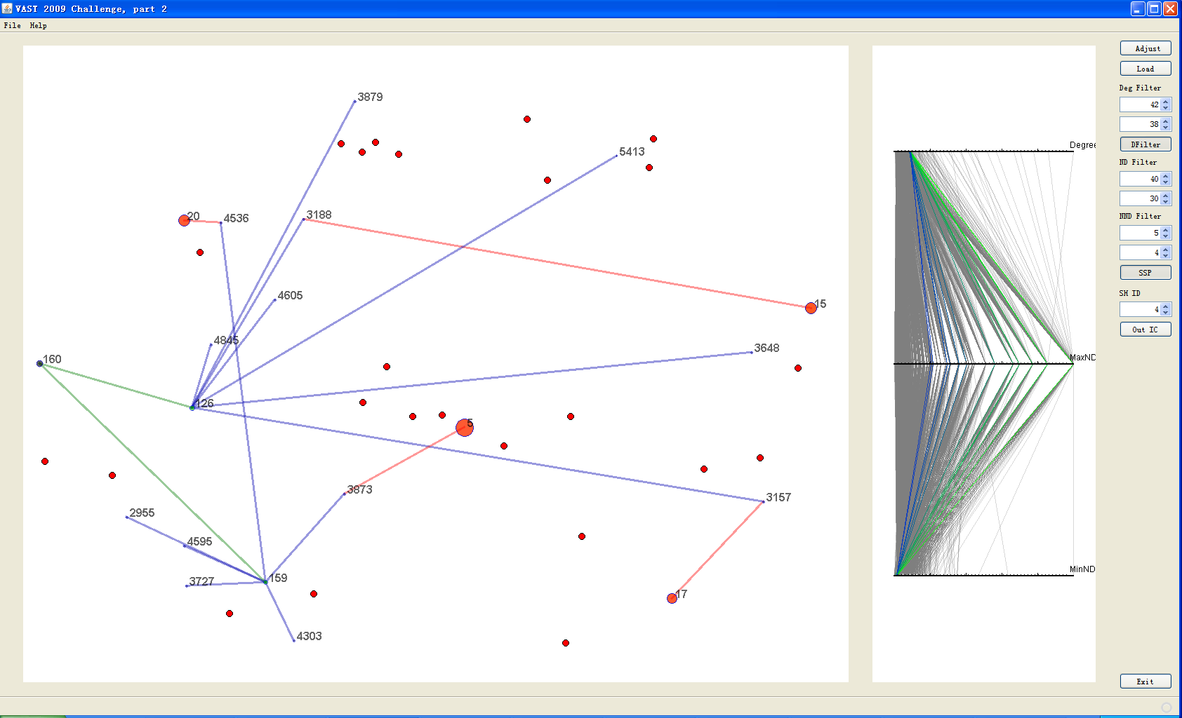
[pic3]
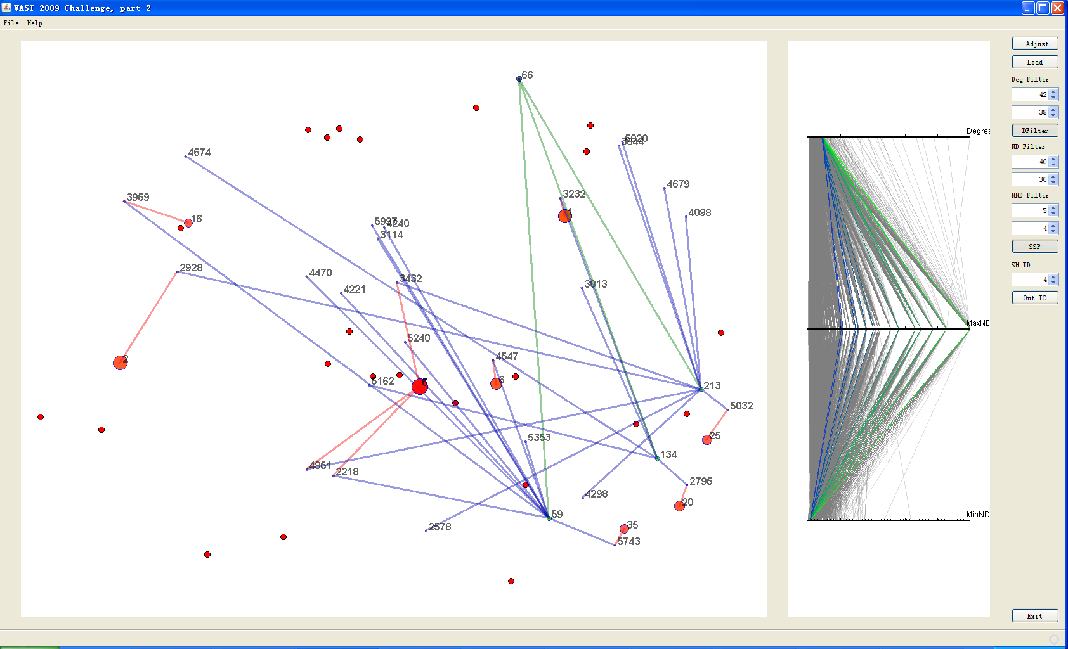
[pic4]
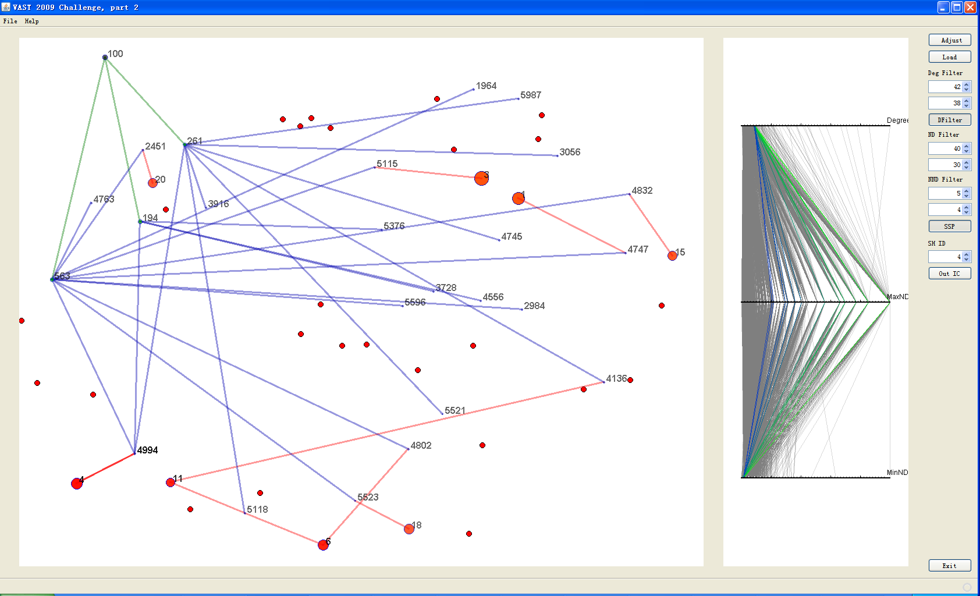
[pic5]
We might take note of the column on the right. Yes, we could set and adjust the search range here. Moreover, the graph could be drawn dynamically while the range changed. Why we designed this interaction but not set a regular range in our code? It was our consideration that the structure A was just a closer one, maybe not that accurate, so we’d better give search within a wider range. For instance, employee's degree was around 40 offered by structure A, we set the upper bound as 38 and lower bound as 40, through which we could face a smaller scale of nodes. Fortunately, we found it. But we wanted to check out any other suspicious data. We expanded the range step by step, (39,41), (38,42), (37,43)…… The red nodes on the panel were more and more, but we only focused on the generated ones. Certainly, we could adjust the other two ranges at same time. Well, it took only several minutes to find this suspicious data and 2 hours more to detect others. We had expanded the range to large enough but nothing more could be found.

Therefore, we conclude from all above, this data with our tool which shows little difference with structure A.

